FORT STREET – YEAR 12 HALF YEARLY – 2007
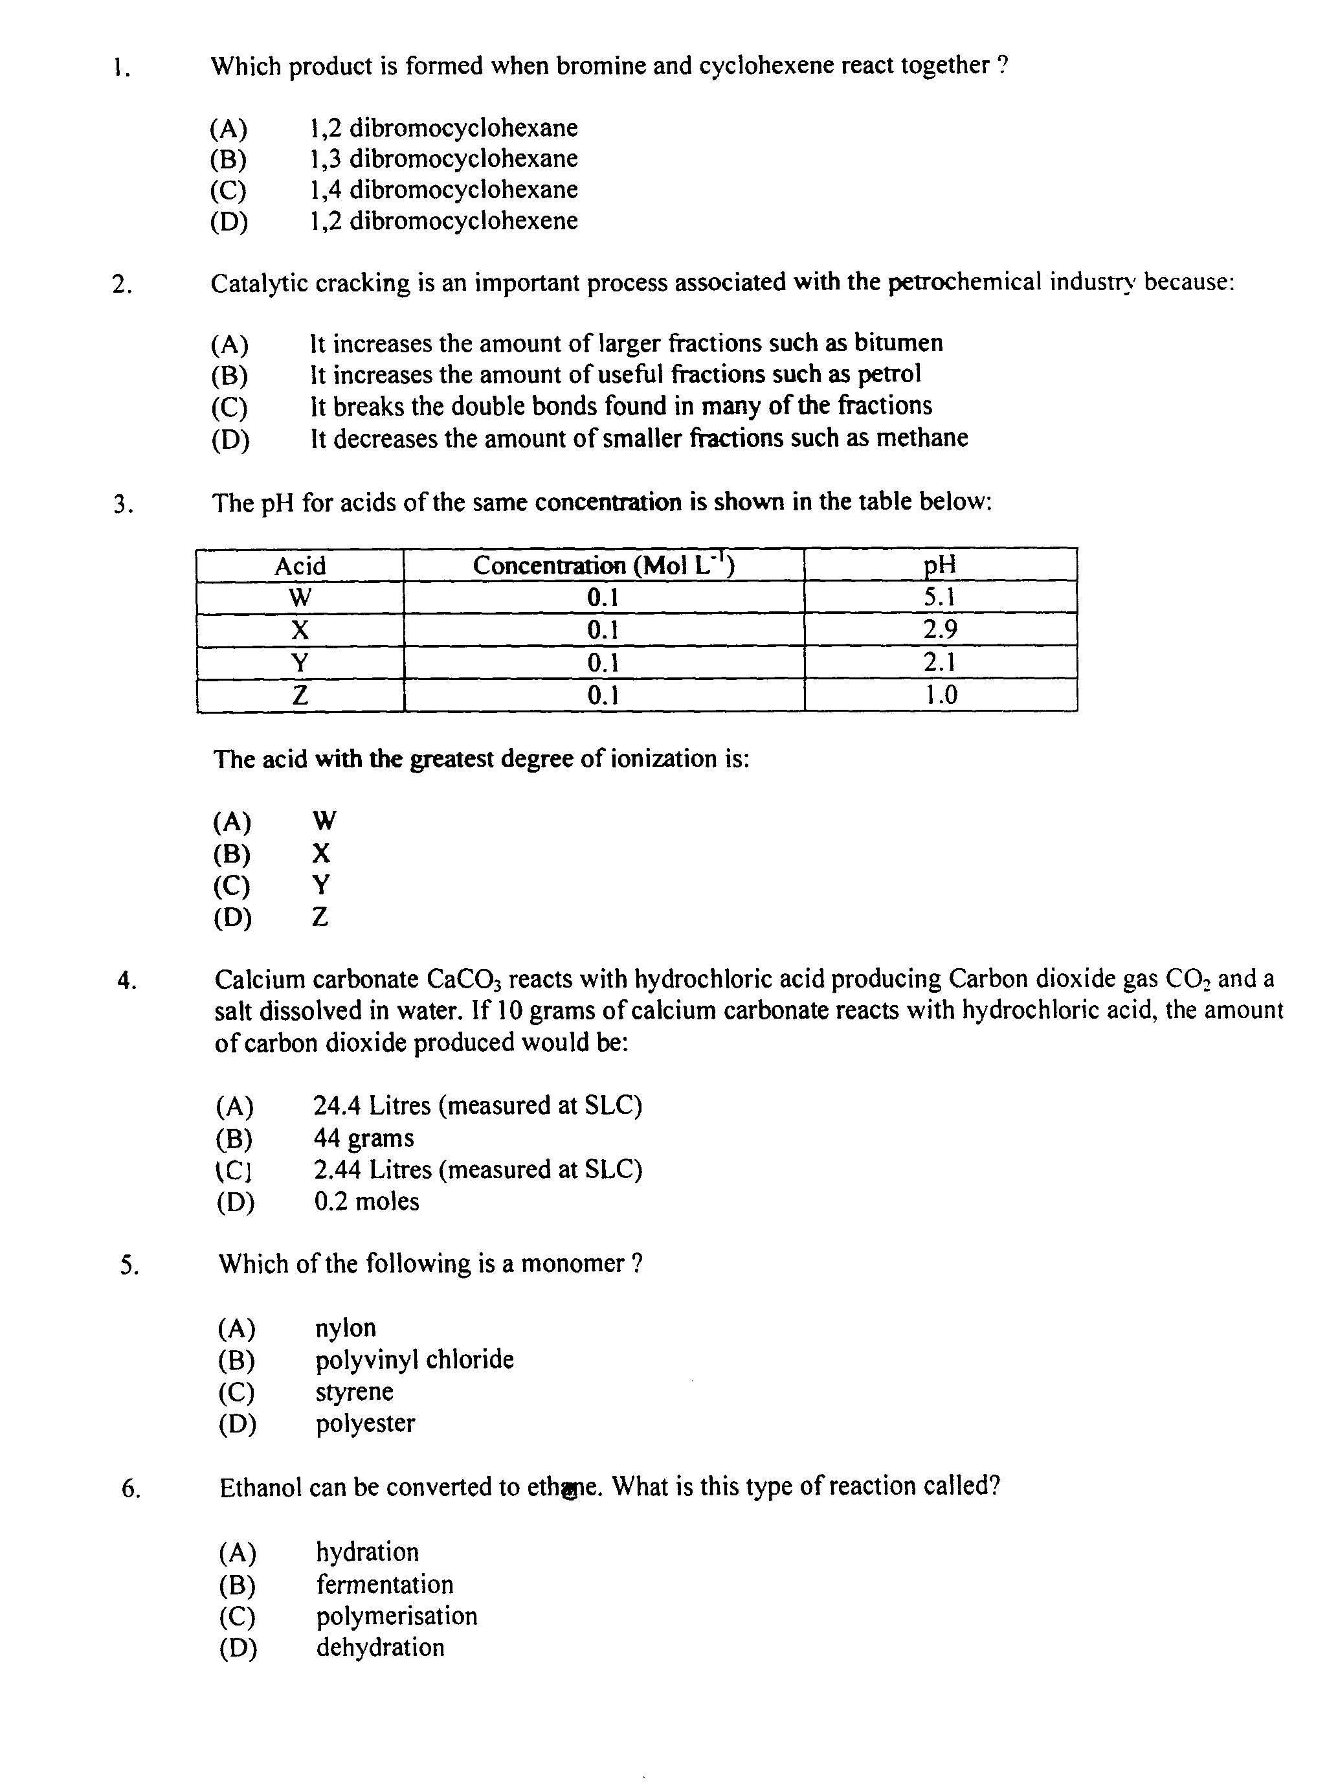

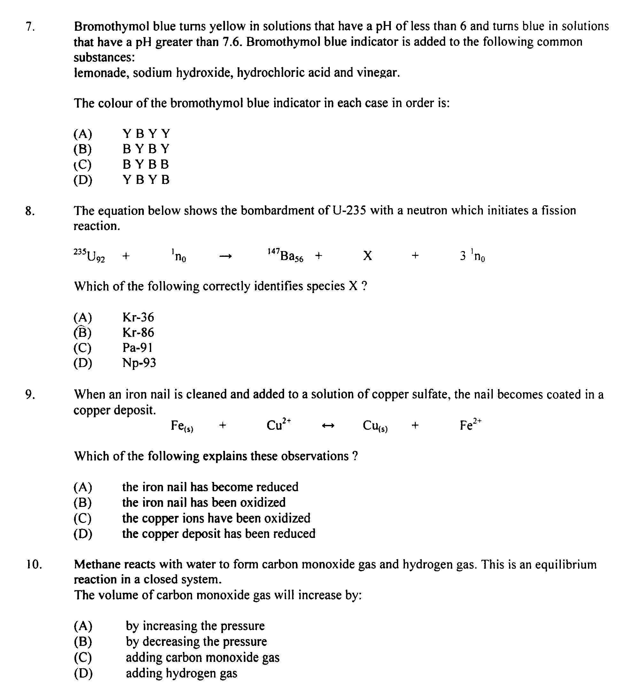

Question 11 (4 marks)

During your HSC course you used models to explain phenomena and/or make predictions

(a) Describe the steps involved in modelling the dehydration of ethanol 2

……………………………………………………………………………………………………………

……………………………………………………………………………………………………………

……………………………………………………………………………………………………………

……………………………………………………………………………………………………………

……………………………………………………………………………………………………………

(b) Discuss the limitation of the model you made 2

……………………………………………………………………………………………………………

……………………………………………………………………………………………………………

……………………………………………………………………………………………………………

……………………………………………………………………………………………………………

……………………………………………………………………………………………………………

……………………………………………………………………………………………………………

……………………………………………………………………………………………………………

……………………………………………………………………………………………………………

Question 12 (2 marks)

Describe how transuranic elements are produced

……………………………………………………………………………………………………………

……………………………………………………………………………………………………………

……………………………………………………………………………………………………………

……………………………………………………………………………………………………………

……………………………………………………………………………………………………………

……………………………………………………………………………………………………………

……………………………………………………………………………………………………………

Question 13 (4 marks)

Analyse benefits and problems associated with the use of a radioactive isotope in an identified industry

……………………………………………………………………………………………………………

……………………………………………………………………………………………………………

……………………………………………………………………………………………………………

……………………………………………………………………………………………………………

……………………………………………………………………………………………………………

……………………………………………………………………………………………………………

……………………………………………………………………………………………………………

……………………………………………………………………………………………………………

……………………………………………………………………………………………………………

Question 14 (3 marks)

Discuss the need for alternative sources of the compounds presently obtained from the petrochemical industry

……………………………………………………………………………………………………………

……………………………………………………………………………………………………………

……………………………………………………………………………………………………………

……………………………………………………………………………………………………………

……………………………………………………………………………………………………………

……………………………………………………………………………………………………………

……………………………………………………………………………………………………………

……………………………………………………………………………………………………………

Question 15 (2 marks)

Describe conditions under which fermentation of sugar is promoted

……………………………………………………………………………………………………………

……………………………………………………………………………………………………………

……………………………………………………………………………………………………………

Question 16 (5 marks)

During your HSC course you performed a first hand investigation to identify the condition under which a galvanic cell is produced

(a) Draw a labelled diagram to indicate the galvanic cell you used, indicate a suitable anode, 3
cathode and the direction of flow of electrons

- Another group of students set up a similar galvanic cell using aluminium electrode in a 1 M solution of aluminium nitrate and a silver electrode in a 1 M solution of silver nitrate.

Calculate the overall E⁰ of this galvanic cell 2

……………………………………………………………………………………………………………

……………………………………………………………………………………………………………

……………………………………………………………………………………………………………
Question 17 (3 marks)
Evaluate the success of current usage of ethanol as an alternative fuel

……………………………………………………………………………………………………………

……………………………………………………………………………………………………………

……………………………………………………………………………………………………………

……………………………………………………………………………………………………………

……………………………………………………………………………………………………………

……………………………………………………………………………………………………………

……………………………………………………………………………………………………………

……………………………………………………………………………………………………………

……………………………………………………………………………………………………………
Question 18 (2 marks)

During your HSC course you performed a first-hand investigation to prepare and test a natural indicator. Describe the method used in your investigation

……………………………………………………………………………………………………………

……………………………………………………………………………………………………………

……………………………………………………………………………………………………………

……………………………………………………………………………………………………………

Question 19 (5 marks)

Evaluate reasons for concern about the industrial origins of sulfur dioxide and oxides of nitrogen and their release into the environment

……………………………………………………………………………………………………………

……………………………………………………………………………………………………………

……………………………………………………………………………………………………………

……………………………………………………………………………………………………………

……………………………………………………………………………………………………………

……………………………………………………………………………………………………………

……………………………………………………………………………………………………………

……………………………………………………………………………………………………………

……………………………………………………………………………………………………………

……………………………………………………………………………………………………………

……………………………………………………………………………………………………………

……………………………………………………………………………………………………………

……………………………………………………………………………………………………………

……………………………………………………………………………………………………………

